Sam Peckinpah

Professor Zhan

GSB 520

**1.1**

CREATE TABLE Student

(

StudentID INT NOT NULL PRIMARY KEY,

StudentName VARCHAR(25)

);

CREATE TABLE Faculty

(

FacultyID INT NOT NULL PRIMARY KEY,

FacultyName VARCHAR(25)

);

CREATE TABLE Courses

(

CourseID CHAR(8) NOT NULL PRIMARY KEY,

CourseName VARCHAR(15)

);

CREATE TABLE Qualified

(

FacultyID INT NOT NULL,

CourseID CHAR(8) NOT NULL,

DateQualified DATE,

FOREIGN KEY (FacultyID) REFERENCES Faculty(FacultyID),

FOREIGN KEY (CourseID) REFERENCES Courses(CourseID)

);

CREATE TABLE Section

(

SectionNo INT NOT NULL PRIMARY KEY,

Semester VARCHAR(7),

CourseID Char(8),

FOREIGN KEY (CourseID) REFERENCES Courses(CourseID)

);

CREATE TABLE Registration

(

StudentID INT NOT NULL,

SectionNo INT NOT NULL,

FOREIGN KEY (StudentID) REFERENCES Student(StudentID),

FOREIGN KEY (SectionNo) REFERENCES Section(SectionNo)

);

CREATE TABLE Assignments

(

FacultyID INT,

SectionNo INT,

CourseID CHAR(8),

FOREIGN KEY (FacultyID) REFERENCES Faculty(FacultyID)

FOREIGN KEY (SectionNo) REFERENCES Section(SectionNo)

FOREIGN KEY (CourseID) REFERENCES Courses(CourseID)

);

**1.2**

Student

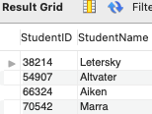

Faculty

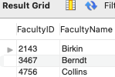

Courses

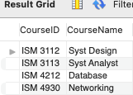

Qualified

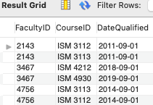

Section

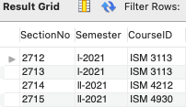

Registration

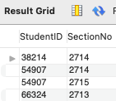

**1.3**

SELECT st.StudentName, se.Semester, se.CourseID

FROM Student st JOIN Registration re JOIN Section se

ON st.StudentID = re.StudentID

AND re.SectionNo = se.SectionNo;

**1.4**

1. INSERT INTO Student VALUES (65798, 'Lopez');
2. DELETE FROM Student

WHERE StudentID = 65798 AND StudentName = 'Lopez';

1. ALTER TABLE Courses

MODIFY CourseName VARCHAR(36);

UPDATE Courses SET

CourseName = "Introduction to Relational Databases"

WHERE CourseID = "ISM 4212";

1. ALTER TABLE Student

RENAME COLUMN StudentName TO StudentLastName;

1. ALTER TABLE Qualified

ADD CONSTRAINT chk_date

CHECK (DateQualified >= '2011-09-01');

**2.1**

CREATE TABLE Tutor

(

TutorID INT PRIMARY KEY NOT NULL,

CertDate DATE,

Status VARCHAR(9)

);

CREATE TABLE Student

(

StudentID INT PRIMARY KEY NOT NULL,

GroupID INT,

ReadScore DECIMAL(2,1)

);

CREATE TABLE Match_History

(

MatchID INT PRIMARY KEY NOT NULL AUTO_INCREMENT,

TutorID INT,

StudentID INT,

StartDate DATE,

EndDate DATE,

FOREIGN KEY (TutorID) REFERENCES Tutor(TutorID),

FOREIGN KEY (StudentID) REFERENCES Student(StudentID)

);

**2.2**

Tutor

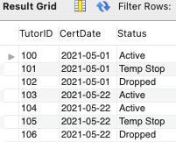

Student

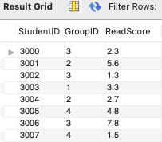

Match_History

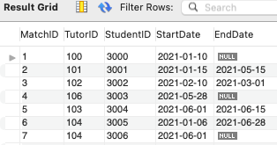

**2.3**

1. ALTER TABLE Match_History

ADD CONSTRAINT TutorID

ADD CONSTRAINT StudentID

FOREIGN KEY (TutorID) REFERENCES Tutor(TutorID),

FOREIGN KEY (StudentID) REFERENCES Student(StudentID),

ON DELETE RESTRICT

ON UPDATE RESTRICT;

1. ALTER TABLE Match_History

RENAME TO Match_Hist;

1. ALTER TABLE Tutor

MODIFY Cert_Date DATE NOT NULL;

ALTER TABLE Student

MODIFY ReadScore DECIMAL (2,1) NOT NULL;

1. CREATE INDEX group_idc

ON Student(GroupID)